# CP Lab 4

**Nabeel Ali BEE173059 Section-3**

//Activity 1

#include <stdio.h>

void pattern(int y, int x);

void main()

{

int rows, columns;

printf("Enter the number of rows: ");

scanf("%d", &rows);

printf("Enter the number of columns: ");

scanf("%d", &columns);

pattern(rows, columns);

}

void pattern(int y, int x)

{

for (int line = 1; line <= y; line++)

{

for (int asterisks = 1; asterisks <= x; asterisks++)

{

printf("*");

}

printf("\n");

}

}

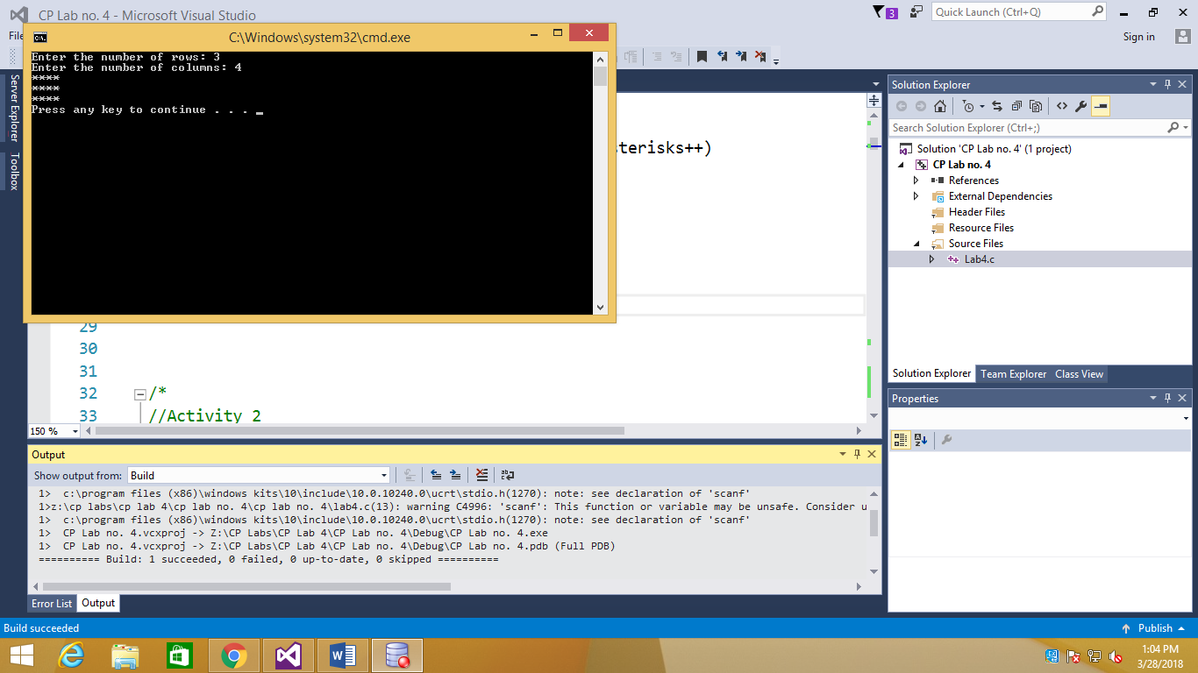

//Activity 2

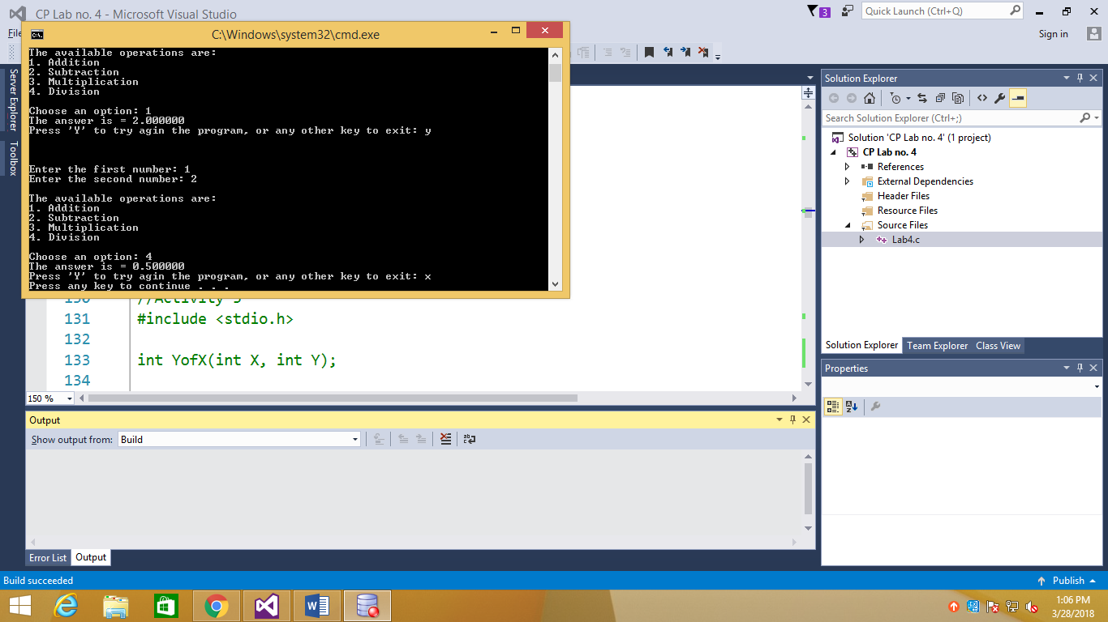#include <stdio.h>

void menu();

float addition(float a, float b);

float subtraction(float a, float b);

float multiplication(float a, float b);

float division(float a, float b);

void main()

{

float num1, num2, out;

int option;

char retry;

do

{

printf("Enter the first number: ");

scanf("%f", &num1);

printf("Enter the second number: ");

scanf("%f", &num2);

printf("\n");

menu();

printf("\n");

printf("Choose an option: ");

scanf("%d", &option);

switch (option)

{

case 1:

out = addition(num1, num2);

printf("The answer is = %f\n", out);

break;

case 2:

out = subtraction(num1, num2);

printf("The answer is = %f\n", out);

break;

case 3:

out = multiplication(num1, num2);

printf("The answer is = %f\n", out);

break;

case 4:

out = division(num1, num2);

printf("The answer is = %f\n", out);

break;

default:

printf("You have entered the wrong value.\n");

}

printf("Press 'Y' to try agin the program, or any other key to exit: ");

scanf(" %c", &retry);

if (retry != 'Y' && retry != 'y')

{

break;

}

printf("\n\n\n");

} while (1);

}

void menu()

{

printf("The available operations are: \n");

printf("1. Addition\n");

printf("2. Subtraction\n");

printf("3. Multiplication\n");

printf("4. Division\n");

}

float addition(float a, float b)

{

float result;

result = a + b;

return result;

}

float subtraction(float a, float b)

{

float result;

result = a - b;

return result;

}

float multiplication(float a, float b)

{

float result;

result = a * b;

return result;

}

float division(float a, float b)

{

float result;

result = a / b;

return result;

}

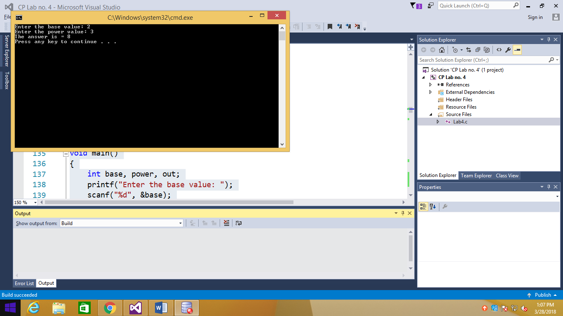//Activity 3

#include <stdio.h>

int YofX(int X, int Y);

void main()

{

int base, power, out;

printf("Enter the base value: ");

scanf("%d", &base);

printf("Enter the power value: ");

scanf("%d", &power);

out = YofX(base, power);

printf("The answer is = %d\n", out);

}

int YofX(int X, int Y)

{

int result = 1;

for (int counter = 1; counter <= Y; counter++)

{

result = result * X;

}

return result;

}

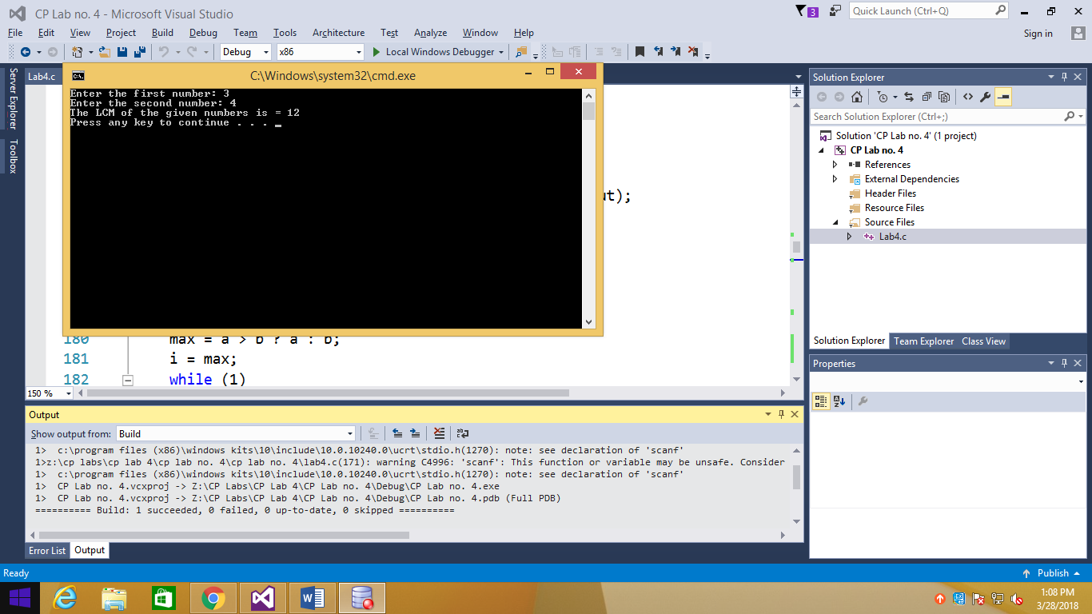

//Activity 4

#include <stdio.h>

int LCM(int a, int b);

void main()

{

int num1, num2, out;

printf("Enter the first number: ");

scanf("%d", &num1);

printf("Enter the second number: ");

scanf("%d", &num2);

out = LCM(num1, num2);

printf("The LCM of the given numbers is = %d\n", out);

}

int LCM(int a, int b)

{

int i;

i = a > b ? a : b;

while (1)

{

if ((i % a == 0) && (i % b == 0))

{

break;

}

i++;

}

return i;

}

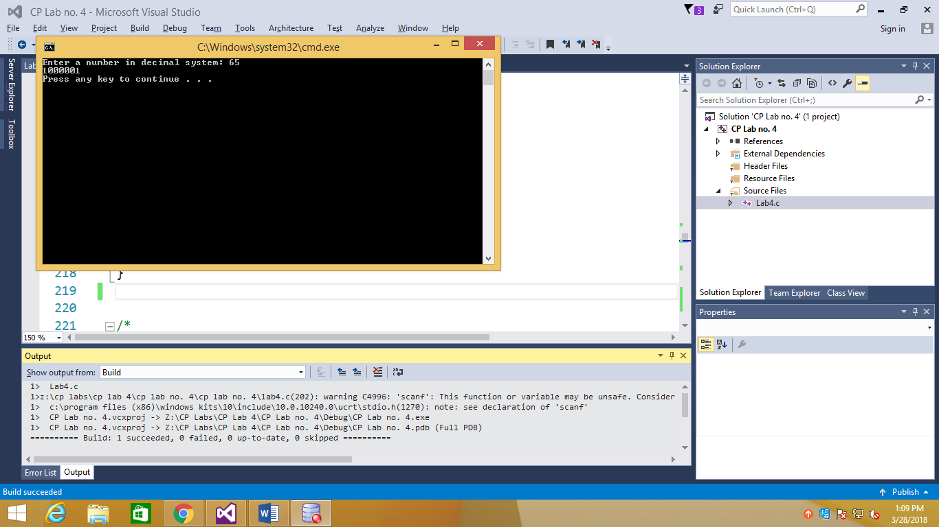//Bonus Activity 1

#include <stdio.h>

int DecimaltoBinary(int input);

void main()

{

int decimal, out;

printf("Enter a number in decimal system: ");

scanf("%d", &decimal);

out = DecimaltoBinary(decimal);

printf("%d\n", out);

}

int DecimaltoBinary(int input)

{

int binary = 0, i = 1;

while (input != 0)

{

binary = binary + (input % 2) * i;

input = input / 2;

i = i * 10;

}

return binary;

}

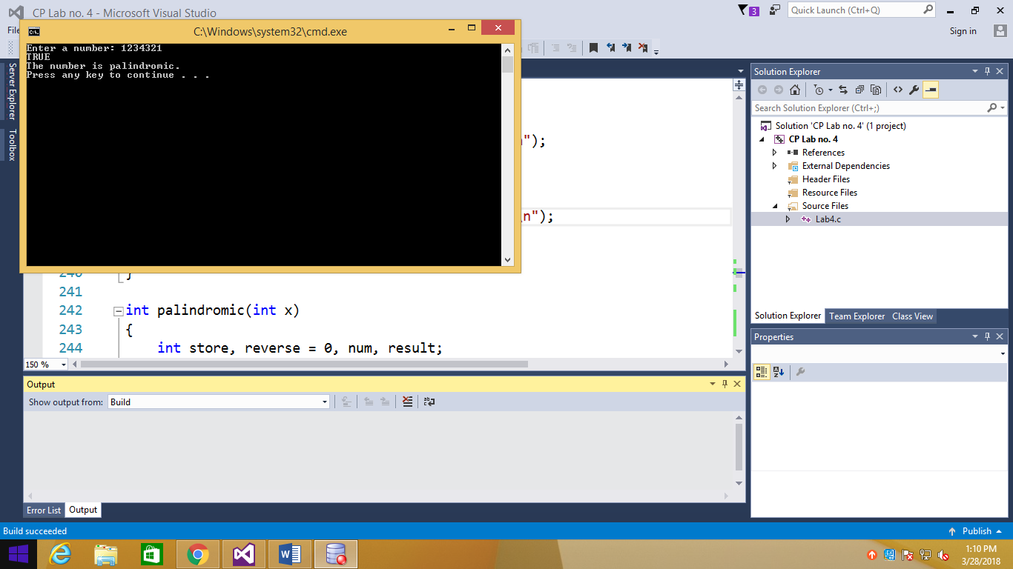//Bonus Activity 2

#include <stdio.h>

int palindromic(int x);

void main()

{

int num, out;

printf("Enter a number: ");

scanf("%d", &num);

out = palindromic(num);

if (out == 1)

{

printf("TRUE\nThe number is palindromic.\n");

}

else

{

printf("FALSE\nThe number is not palindromic.\n");

}

}

int palindromic(int x)

{

int store, reverse = 0, num, result;

store = x;

while (x > 0)

{

num = x % 10;

x = x / 10;

reverse = reverse * 10 + num;

}

return (reverse == store);

}

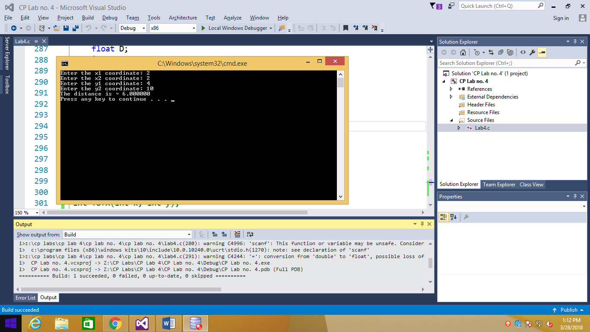//Bonus Activity 3

#include <stdio.h>

#include <math.h>

float distance(int x1, int x2, int y1, int y2);

main()

{

float D;

int x1, x2, y1, y2;

printf("Enter the x1 coordinate: ");

scanf("%d", &x1);

printf("Enter the x2 coordinate: ");

scanf("%d", &x2);

printf("Enter the y1 coordinate: ");

scanf("%d", &y1);

printf("Enter the y2 coordinate: ");

scanf("%d", &y2);

D = distance(x1, x2, y1, y2);

printf("The distance is = %f\n", D);

}

float distance(int x1, int x2, int y1, int y2)

{

float D;

int x, y;

x = x2 - x1;

y = y2 - y1;

D = sqrt(pow(x, 2) + pow(y, 2));

return D;

}

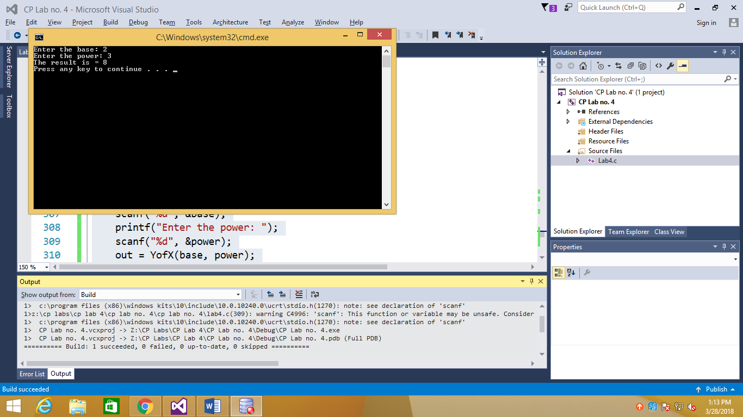#include <stdio.h>

int YofX(int x, int y);

main()

{

int base, power, out;

printf("Enter the base: ");

scanf("%d", &base);

printf("Enter the power: ");

scanf("%d", &power);

out = YofX(base, power);

printf("The result is = %d\n", out);

}

int YofX(int x, int y)

{

if (y == 0)

{

return 1;

}

else

{

return (x * YofX(x, y - 1));

}

}